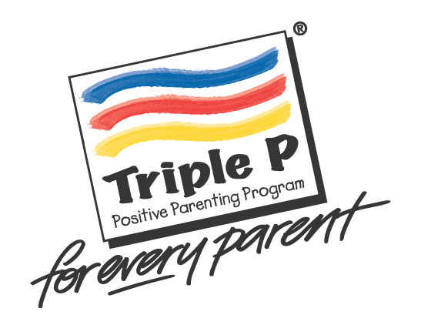

**Triple P Positive Parenting Program**

**at the CMHRT**

**What is Triple P?**

* Group parenting program based on research evidence and used in 35 countries
* Provides tips and strategies to suit the individual needs of your family
* Includes a handy workbook with parenting tools and information

**When does it start?**

* Will be delivered via teletherapy (need a computer and webcamera)
* Wednesdays from 6 to 7:30 pm from March 24 to May 12, 2021
* 6 in class 90 min group sessions: March 24; Mar 31; April 7; April 14; April 21; May 12 2021
* 2 individual 30 min telephone sessions: April 28; May 5 2021

**Who is it for?**

* Parents of children ages 3 to 11 years
* Parents seeking strategies to manage challenging child behaviors
* Parents wanting to learn new ideas, to reduce parenting stress, or to feel more confident in their parenting, especially during a pandemic

**What does it cost?**

* The group program fees are $200 for the 8 week program
* There is an additional cost of $30 for the parent workbook, which will be mailed out via Canada Post in advance of the group
* Subsidies are possible. Since the group is facilitated by a registered psychologist, these psychological services may be eligible for reimbursement from insurance benefits.

**How do I sign up?**

* Interested parents should email the UW CMHRT at **cmhrtintake@uwaterloo.ca** and should say that they are interested in Triple P. Spaces are limited.
* We will arrange a short telephone call to discuss your parenting goals and to determine whether this program can best meet your needs.